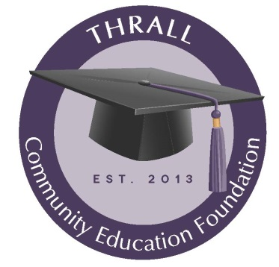
2022-2023 Education Enhancement Grant
Fall 2022
The purpose of the Thrall Community Education Foundation Education Enhancement Grant (the Grant) is to provide funds for educators at Thrall ISD for projects, materials, software, hardware, supplies, conference/seminar registration fees and other items that will allow them to enhance the education provided in their classroom. The educators of Thrall ISD have been, and will continue to be, crucial to the success of the fundraising efforts of the TCEF therefore the Foundation wants to show its support of the educators. There is no minimum or maximum amount for a grant application through awarded grants. If awarded, grants will be paid to Thrall ISD and designated to the recipient. Grant requests may not be made for reimbursement of purchases that have been made prior to the Grant being awarded. Grant funds may be used in conjunction with funding from other sources in order to implement a program or purchase.
All grant applications should be typed and must address the following:
- Name, grade level and/or subject taught by the applicant.
- A brief explanation of what the grant will be used for, the amount of funds being requested from TCEF and the expected total cost of the project/item. Include the name(s) of any additional funding sources, if applicable to your application.
- An explanation of how being awarded the grant will allow the applicant to enhance the education they provide to the students of Thrall ISD.
- How long the educator will be able to utilize the requested item or items.
- Contact information for the applicant, for notification purposes.
- The grant application must be signed by the applicant and the applicant’s principal.
The request does not have to be lengthy or complex but must address the items specified above in order to be considered for funding. The Thrall Community Education Foundation understands that what an educator needs to enhance the education of their students varies by the grade level of the students and encourages teachers at all grade levels to submit an application. Awarded funds must be utilized during the Fall of the 2022 school year.

All grant applications must be scanned and emailed to tcefgrants@gmail.com no later than 5 p.m. on Friday, June 3, 2022.
A committee of at least three TCEF members and other members of the community, if available, will review all applications to ensure all criteria have been addressed and that the education of Thrall ISD students will be enhanced if the grant is awarded. The committee will then determine how many eligible grants can be awarded and either fully or partially funded based on the total amount of funds being requested. The recommendations will be presented to the TCEF board for final approval.
Grant recipients will be notified of the amount of funding they have been awarded as soon as possible after the TCEF board votes on final approval. A grant agreement must be signed by the recipient before funds can be disbursed to Thrall ISD. Any grants that are not awarded will receive an explanation of why their application did not meet the requirements.
Recipients that choose not to use the awarded funds should notify TCEF, in writing, of their decision as soon as possible.
A second grant application period may be opened for any funds that are not awarded prior to the beginning of the school year or awarded funds that teachers choose not to use. If this is necessary, an announcement will be sent out through Thrall ISD. The grant application requirements will not change for the second application period.

Any questions about this grant should be directed to Lisa Manning, TCEF VP of Programs, via email at tcefgrants@gmail.com or phone at 512-569-9641.

